Report
Student ID: 201511345
COMM2754

Welcome to my report where I explain the process for creating my art piece, as well as how I hosted it and some other interesting things. Whilst I started out by creating a WordPress site and theme I quickly realized I wasn’t really capable of it and decided to change the route I took. The creative coding was my second favorite task of the weeks, as “with the creative coding movement, artists have transcended the dependence on using only pre-existing software for creating computer art.” (Bergstrom, 2015). The ability to create art without the need of software such a photoshop fascinates me so I thought I would try to make some artwork of my own.
Process
The first thing I did to start my creative coding piece was to install the p5.js complete library and save it to my local area. I then set up set up a server on MySQL databases, so that the code has somewhere to run from (see fig. 1). I made sure to add myself as a privileged user so that I could access and use all the tools I needed.
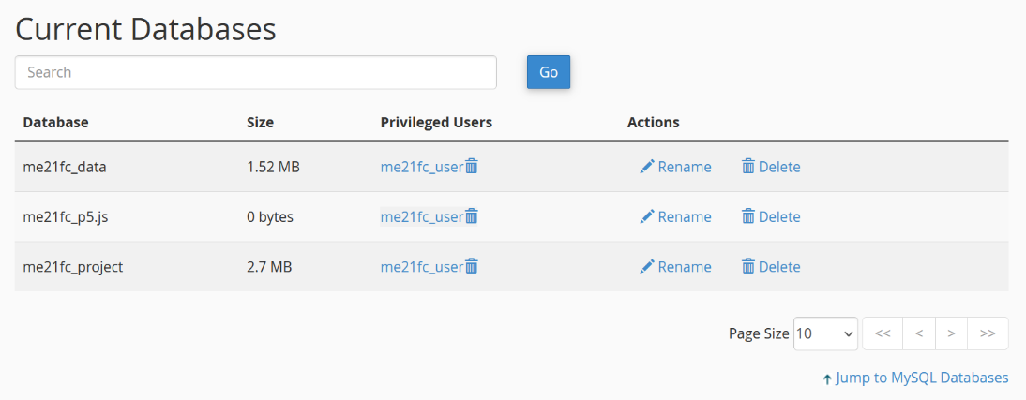 fig. 1
Once I had done this I realized it was completely unnecessary because I only needed my cPanel server and could create it locally. I could then just upload it to my cPanel space to test it server side once I had written it on my local machine. After this I got annoyed ay myself that I had spent half an hour doing this, and then moved on to working on the creative piece.
Next I put together a very simple webpage in which I linked the P5.js library to the site (see fig. 2). I did this so that when I created a piece of art online and then added it to my site, the site would be able to use the library resources so that the artwork wouldn’t break.
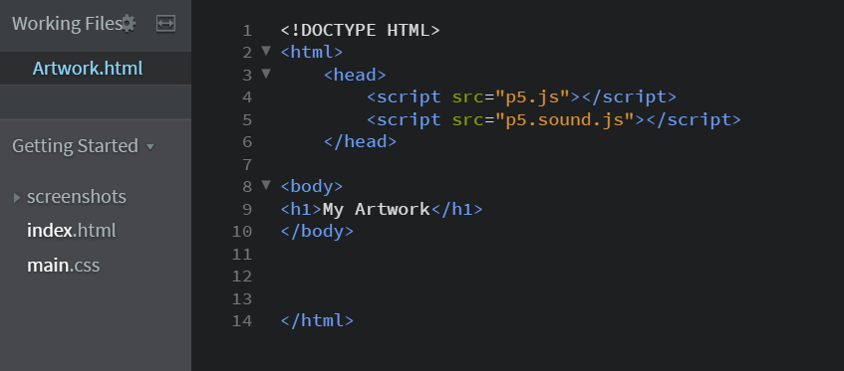 fig. 2

After this I moved my coding over to my local machine so that I could work on my JavaScript on Brackets, as I preferred this to the online version. I made sure to upload my work to cPanel whenever I tested it, so that it could run properly. I started to write code for generating effects on an already created image (see fig. 3) and encountered an error where the image just loaded infinitely.
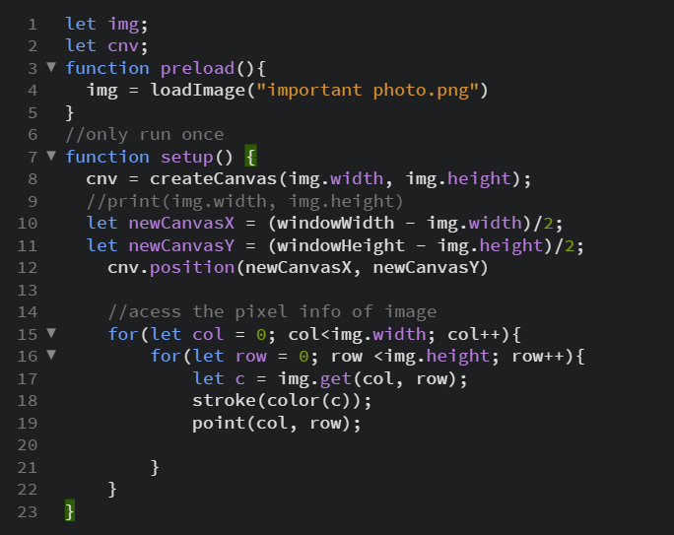 fig. 3
I ended up managing to fix this issue by removing the p5.js.sound file. For some reason it was causing an error with the loading of the images, and once it was removed the image would load. The image I had at the time was a place holder and was very large, so took a while to load. The result was a low resolution image displaying in the center of the page (see fig. 4).
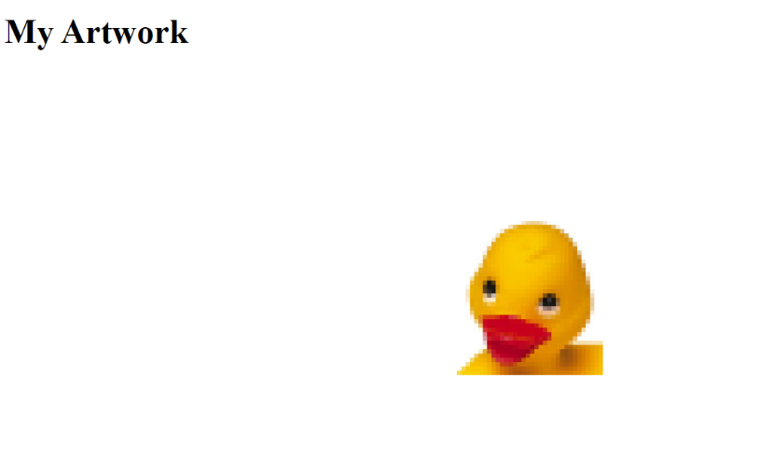 fig. 4
Next my process was to create an effect that would generate over the image. I increased the stroke width and made the image only access one in every 10 pixels, rather than every single one. This resulted in an artistic effect over the original image (see fig. 5). I attempted to add the original image side by side with the new one but couldn’t get it to work. I tried adding the image both with HTML and CSS code, as well as JavaScript but it just kept displaying behind the coded image.
[Note: The image doesn’t display in Firefox, but does in Microsoft Edge. I’m not sure about other browsers.]
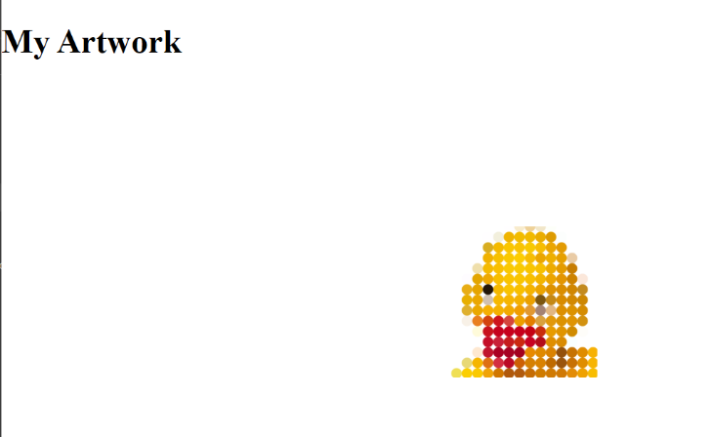 fig. 5
After this I decided to create this effect but with some work that interested me, and play with the code more until I received and interesting and cool work of art. (see fig. 6 and 7). The resulting image was pretty cool and the code seemed robust as far as I can tell.
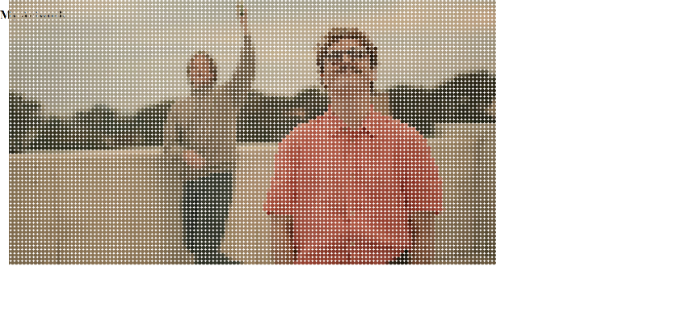 fig. 6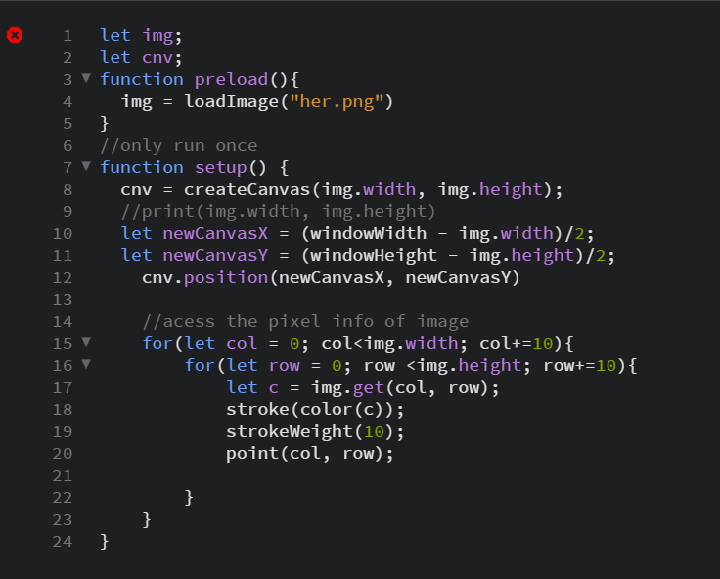 fig. 7
The next thing I focused on was getting the image to display well on the page, underneath the title. I achieved this by putting the JavaScript file in my HTML code into a <div> (see fig. 8); as well as removing the canvas positioning code in the JavaScript. I then used CSS to align it under the <h1> title (see fig. 9). Unfortunately I couldn’t get the image to align to the center of the page or resize it but I managed to get the padding working.
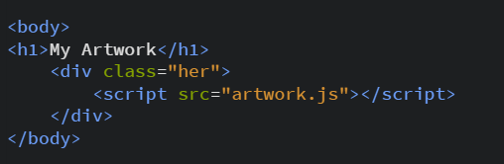 fig. 8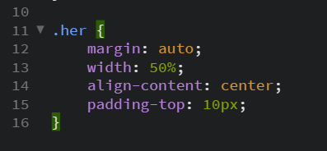 fig. 9
References:
- Bergstrom, & Lotto, R. B. (2015). Code Bending: A New Creative Coding Practice. Leonardo (Oxford), 4

- 8(1), 25–13. https://doi.org/10.1162/LEON_a_00934

